Architecture Document

Travel Manager

By: Robin Velthuys, Quinn van Veen, Lloyd Zalen, Rene Roets and Joris van Roy

Table of Contents

Stakeholders 3

Architecture 4

User Stories 4

Component Diagrams 5

C1 5

C2 5

# Stakeholders

We have the following stakeholders in our project:

* Product Owner
* Maintainer
* Google

The Product Owner is our teacher Samuil in our case. The biggest concern of him is that we have to show the following with our project:

* The student can apply an agile method (Scrum) and can function in a team.
* The student can design and document a software-architecture in an agile project.
* The student can apply testing techniques in an agile project.
* The student can develop a high-quality software product.
* The student can implement the proces of GUI design (design, test, implement)
* The student can internationalize and localize a software application.
* The student can define correct research questions.
* The student can apply relevant research techniques to answer the research questions.
* The student can describe his/her work in a structured way, making use of the research cycle.
* The student can repport orally the results of an assignment .
* The student can collaborate with fellow students, teachers and company professionals.
* The student can receive and process feedback on his/her performance in an ICT context.
* The student can define a project setup plan.

For the maintainers which is us the developers it’s important to make the code clear and maintainable.

Google doesn’t have too many concerns, they probably don’t even know we are making this project.

# Architecture

## User Stories

|  |  |  |  |  |
| --- | --- | --- | --- | --- |
| **#** | **Who** | **What** | **Why** | **Priority** |
| 1 | Group Traveller | create a private trip | travel with friends | High |
| 2 | Group Traveller | add a marker to the map | pinpoint a point of interest | High |
| 3 | Group Traveller | manage finances | to keep track of IOUs | High |
| 4 | Traveller | create a profile | to use the app | High |
| 5 | (Group) Traveller, Admin | login | to access my data | High |
| 6 | Traveller | join a trip | to travel with other people | High |
| 7 | Trip Owner | invite a friend | so they can join the trip | High |
| 8 | Group Traveller | chat with other people in the trip | to communicate with the other members | High |
| 9 | Group Traveller | see the trip map | to know where im going on the trip | High |
| 13 | Solo Traveller | filter irrelevant trips | so i can find the perfect trip for me | High |
| 11 | Solo Traveller | find a trip | to travel with other people | High |
| 14 | Group Traveller | leave a trip | because i dont want to go | Medium |
| 17 | Trip Owner | edit a trip | to change the details of the trip such as time | Medium |
| 22 | Trip Owner | Post trip notifications to trip feed | To easily share information | Medium |
| 10 | Group Traveller | upload pictures | to share it with other members | Low |
| 12 | Traveller | see sights of a particular country | to know what i can do in a country | Low |
| 15 | Traveller | add locations to trip history | to show where i`ve been | Low |
| 16 | Admin | a trip to be deleted after the final member leaves | to clean the database | Low |
| 18 | Trip Owner | change rights of users within trip | to manage the trip | Low |
| 19 | Trip Member | suggest a Traveller to be invited | to expand the group of travellers in the trip | Low |
| 20 | Traveller | Report people | To notify an admin on bad behaviour | Low |
| 21 | Admin | Respond to user reports | To keep the community clean | Low |
| 22 | Solo Traveller | Rate a traveller | To inform other travellers of the experience they had wirh the rated traveller | low |

## Models

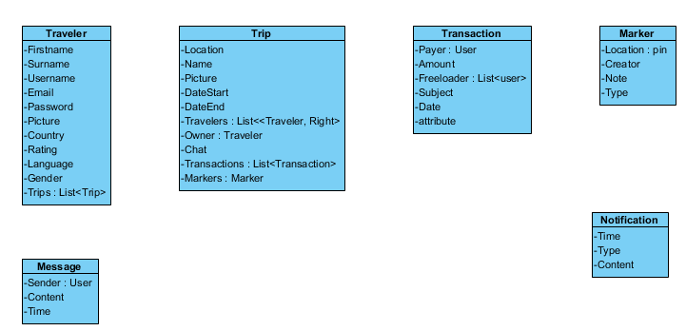

# Component Diagrams

## C1

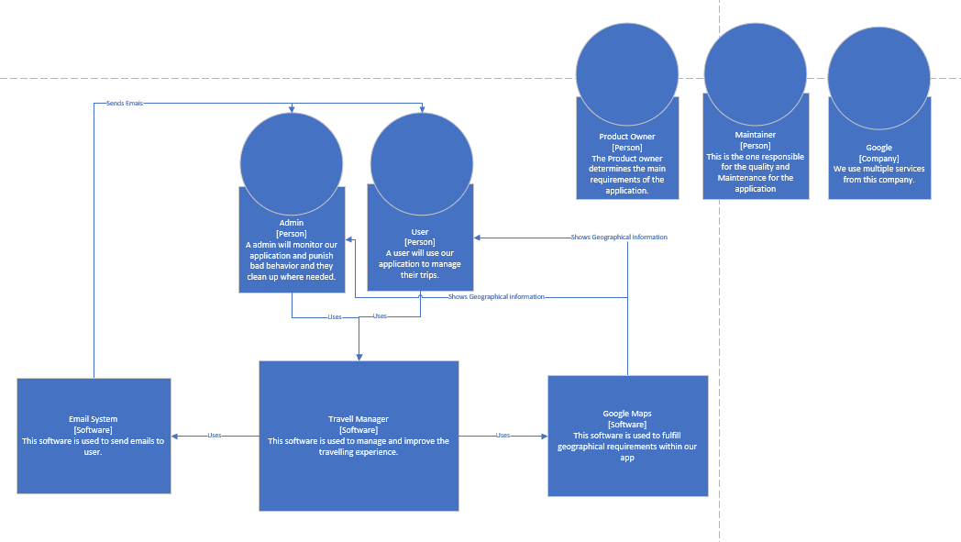

## 

## C2

